Bank Configuration Portal – User manual

Contents

First time setup 3

Database setup 3

Registering new users 4

Logs setup 5

Deploying the application using IIS 6

IIS Installation 6

Deployment 9

Configuring self-signed SSL certificates 16

Automatic session deletion 21

Login 30

Branches 31

Counters 33

Services 34

Language 35

Using the Screens API 36

Authentication 36

Unfiltered results 36

Filtering by branch 36

Filtering by counter 36

# First time setup

## Database setup

First time setup requires SQL Server Management Studio (SSMS) to be installed on your machine.

Open the file named "DB_setup.sql" using SSMS, then open the "Query" menu in the menu bar, and click "SQLCMD Mode".

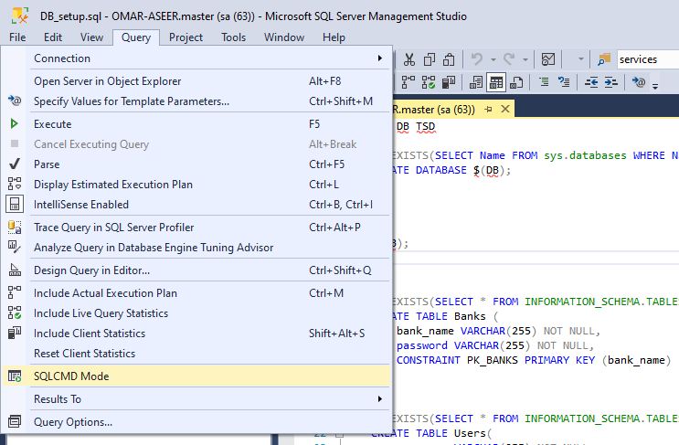

Make sure you’re on the master database, then click "Execute".

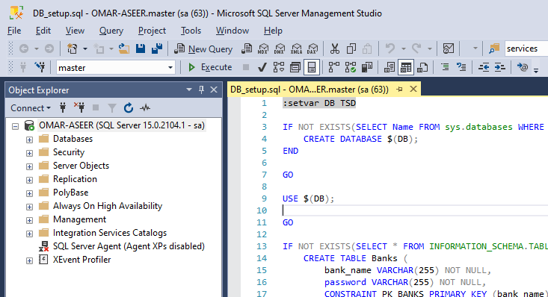

## Registering new users

Registering new users can be done manually using SSMS. Open SSMS and create a new query.

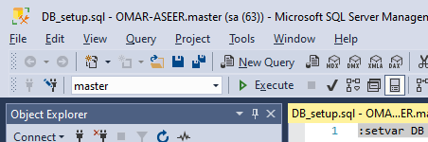

Once you create the query, make sure that it is set to execute on the correct database (TSD by default).

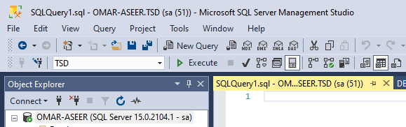

Paste or type the following query into the main window:

INSERT INTO Users (username, password, bank_name) VALUES ('your_username', 'your_password', 'your_bank_name');

Replace the red text with the desired values. Make sure you keep the single quotes.

For example, to create a user with the username "Omar", the password "pass1", and the bank "bank1", the query should look like this:

INSERT INTO Users (username, password, bank_name) VALUES ('Omar', 'pass1', 'bank1');

## Logs setup

This application logs all errors using the windows event viewer. The setup utility creates the log event source, which is necessary for the application to log errors and other events.

To run the setup utility, locate the executable named "Setup.exe", right-click it, then click "Run as administrator". Note that you need administrator permissions to perform this action.

You will get a prompt to confirm that you want to make changes. Click "Yes".

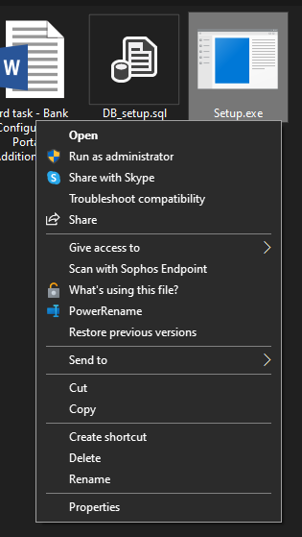

A console window should open up with the following output.

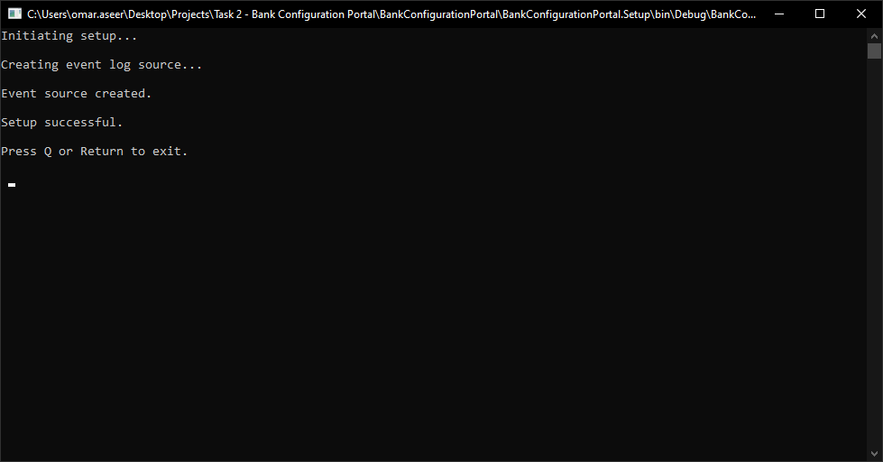

To view these logs, open "Event Viewer", expand "Applications and Services Logs", then click "BankConfigurationPortal".

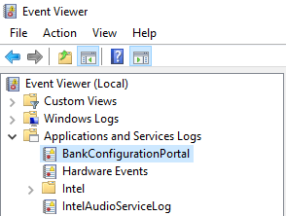

## Deploying the application using IIS

### IIS Installation

In order to deploy the application, you need to have Internet Information Services (IIS) installed on your machine. Follow the steps below to install it. Note that you need administrator permissions to install IIS.

1. Open the start menu and search for "Turn Windows features on or off".

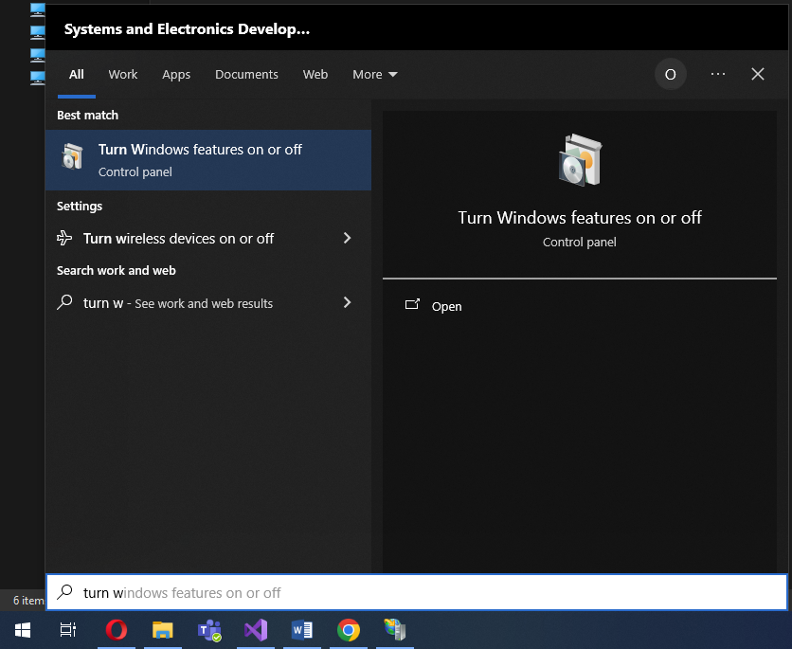

1. Once the window is open, scroll down to "Internet Information Services" and expand it using the + sign.

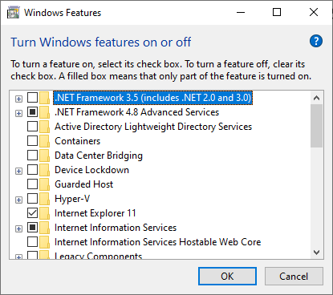

1. Expand "Web Management Tools", and make sure "IIS Management Console" is checked.

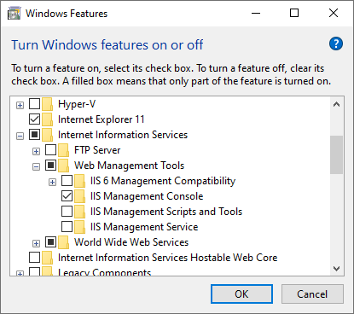

1. Expand "World Wide Web Services" then expand "Common HTTP features".

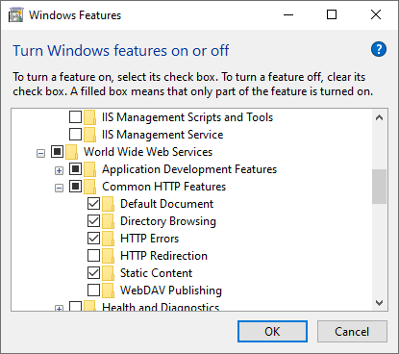

1. Make sure that "Default Document", "Directory Browsing", "HTTP Errors" and "Static Content" are checked.

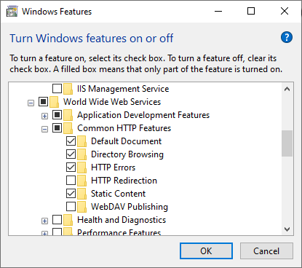

1. Expand "Application Development Features" and make sure ".NET Extensibility 4.8" and "ASP.NET 4.8" are checked.

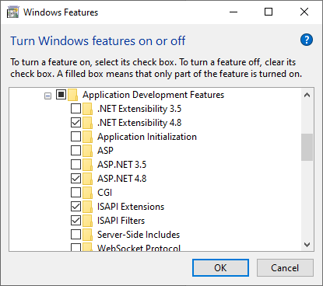

1. Click "OK", and wait for Windows to install the features. If prompted, reboot your machine.

### Deployment

1. Copy the folder named "BankConfigurationPortal - Release" into "C:\inetpub\wwwroot".
2. Open IIS Manager and expand your localhost entry in the "Connections" panel.

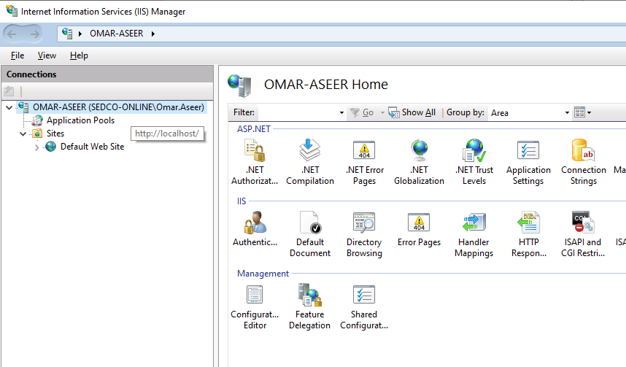

1. Right-click "Sites", and click "Add Website…".

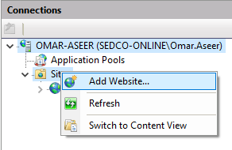

1. Type in the name of the application in the form, then click on the ellipses (…) next to the "Physical path" text box.

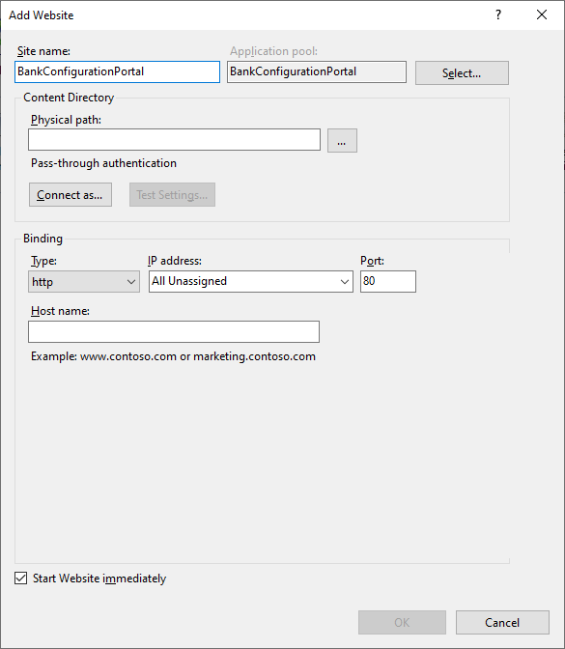

1. Browse for the folder named "BankConfigurationPortal - Release" and select it, then click "OK".

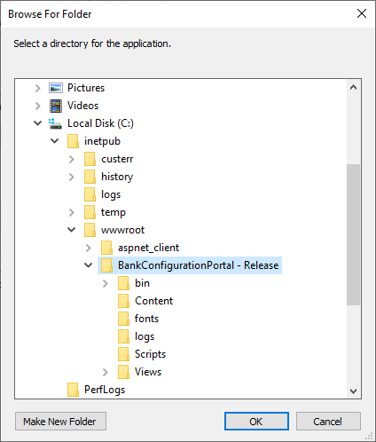

1. Choose a port for the website. Port 80 is usually taken as the port for the default website in IIS, so this example chooses port 81.

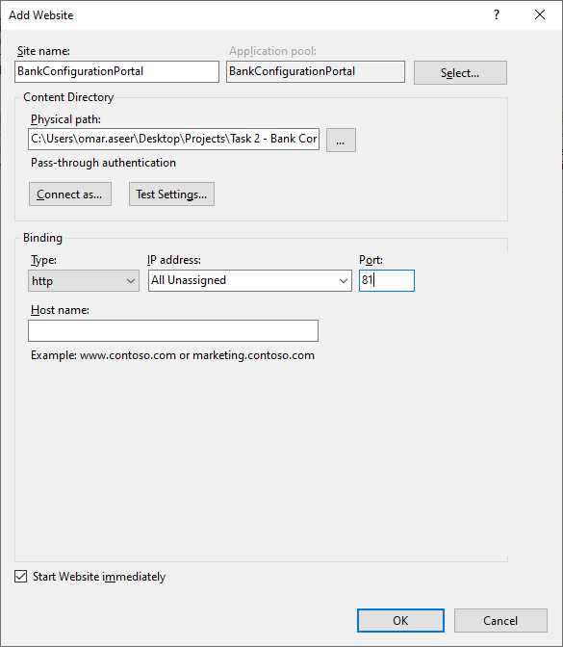

1. Click "OK".

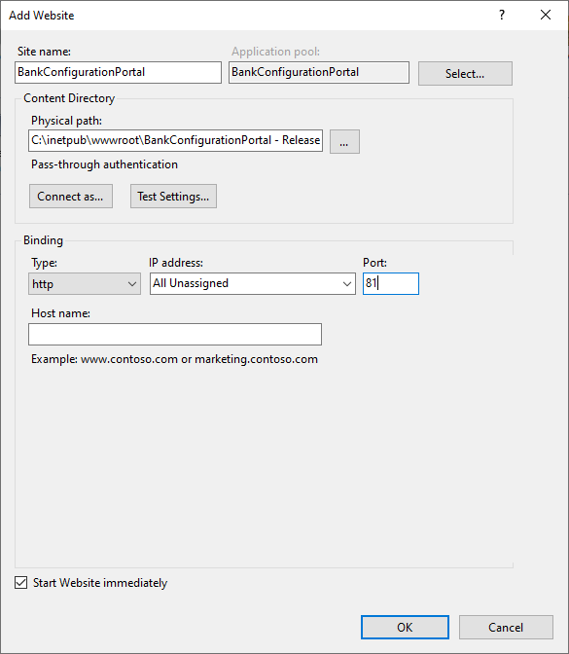

1. You should be able to see the newly added website in the list on the "Connections" panel.

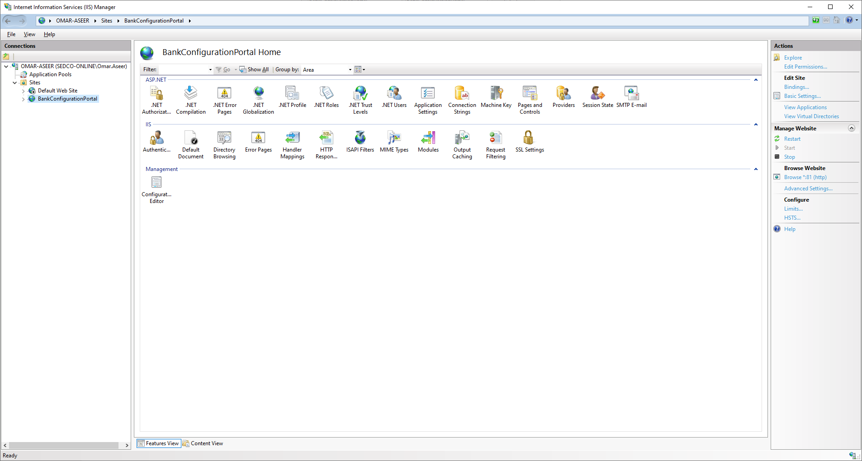

1. Open SSMS and connect to your server.
2. In the "Object explorer", Expand the "Security" node by clicking the + sign.

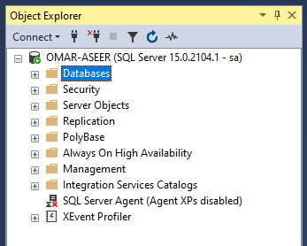

1. Under the "Security" node, you will find a node named "Logins". Right-click it, then click "New Login…".

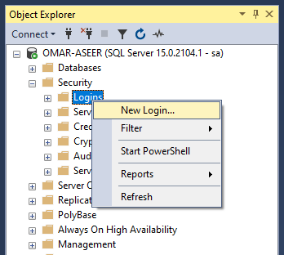

1. In the "Login - New" window, type "IIS APPPOOL\<your application pool name>" into the "Login name" text box. Replace "< your application pool name >" with the name of the application associated with the website. Unless it was changed manually, it is going to be the same as the website name that you chose in step 4.

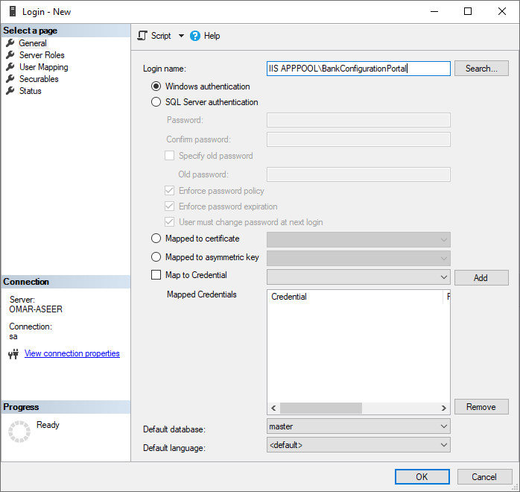

1. Click "User Mapping" in the left side panel.

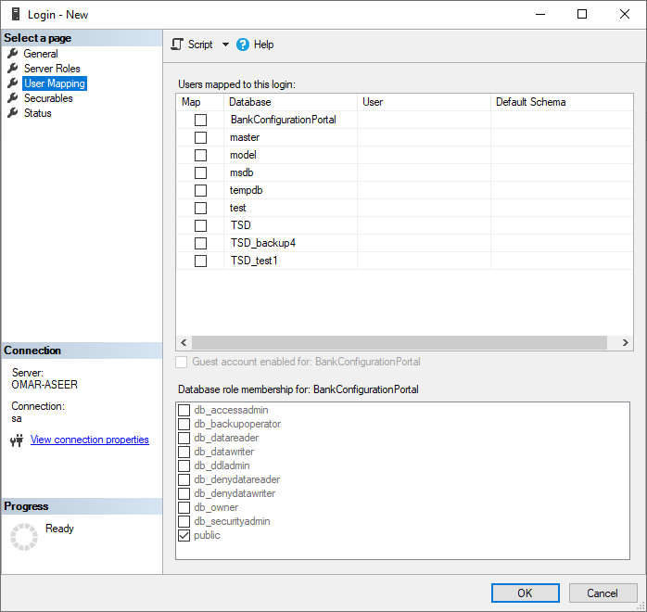

1. Locate the name of the database you created during database setup ('TSD' by default), and make sure the "Map" textbox next to it is checked.

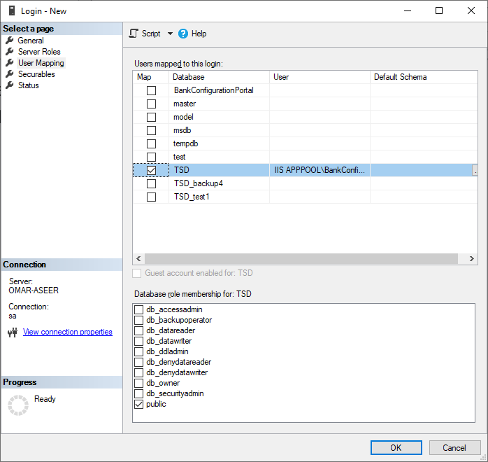

1. In the bottom panel, check "db_datareader" and "db_datawriter".

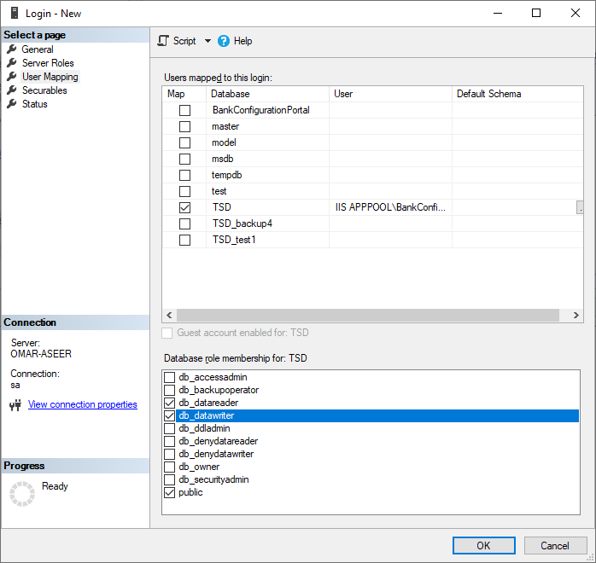

1. Click "OK".
2. Back in IIS Manager, select the website if it is not already selected, then, in the "Actions" panel on the right side, click "Browse *:81 (http)". If you picked a different port number, you should be able to see that port number instead of 81.



1. The website will now be opened in your default browser.

### Configuring self-signed SSL certificates

In order to safely use the API, which requires basic authentication, you need to configure SSL for the application using the steps below.

1. Open IIS Manager and select the server that your website is running on.

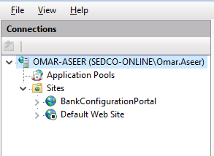

1. In the main window, double-click "Server Certificates".

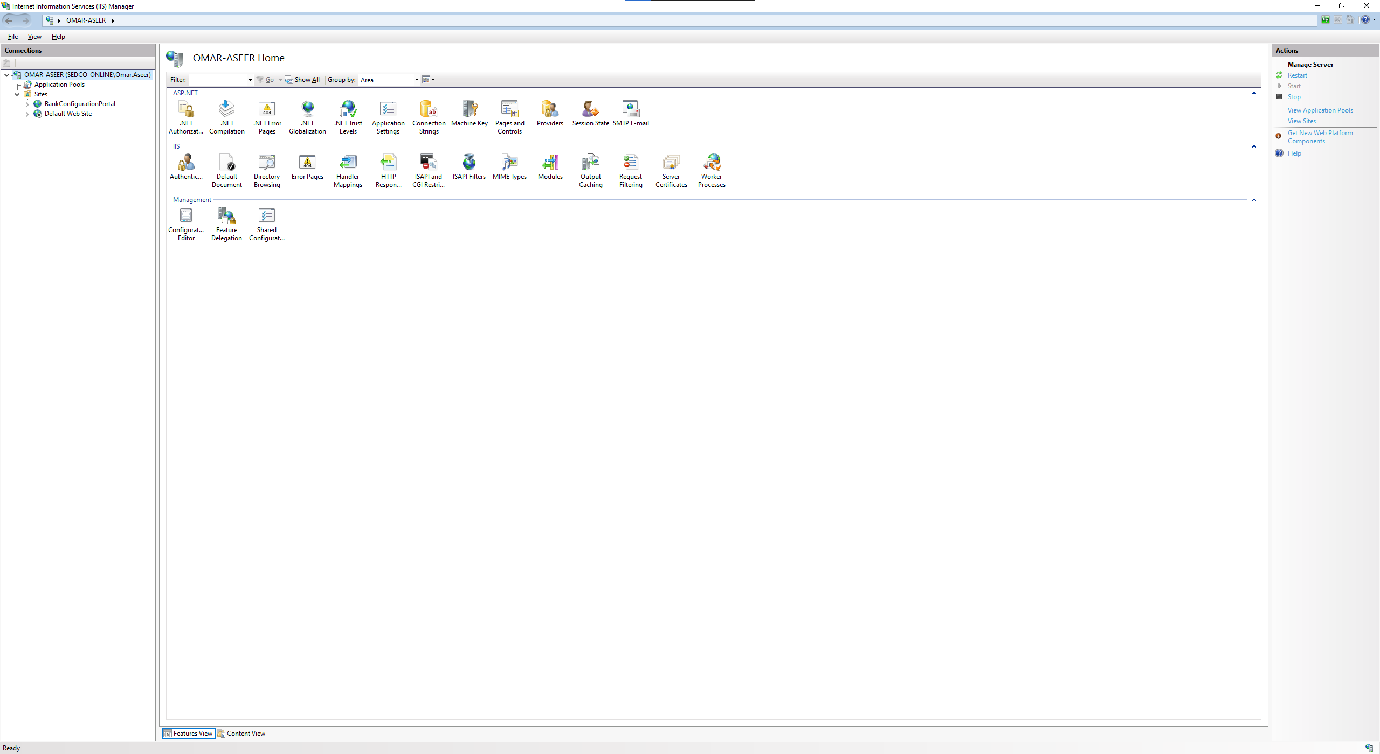

1. In the "Actions" panel on the right side, click "Create Self-Signed Certificate…".

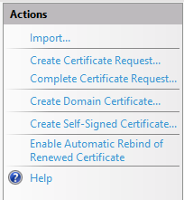

1. Type in a name for your certificate, then click "OK".

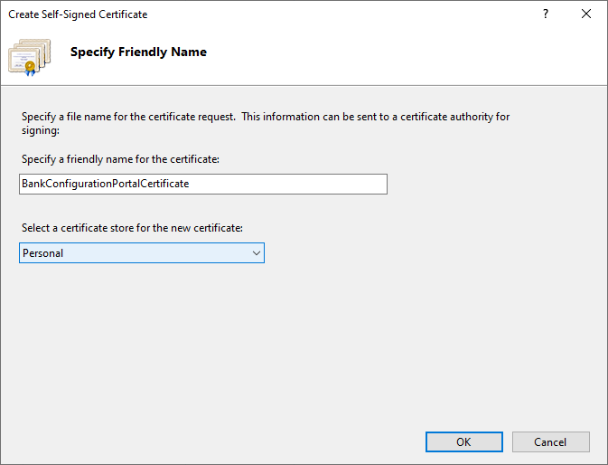

1. Navigate back to your website in the "Connections" panel on the left side.

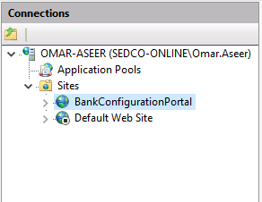

1. In the "Actions" panel, click "Bindings…".

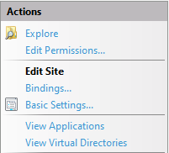

1. Click "Add…".

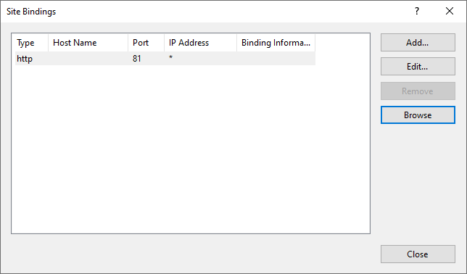

1. In the "Type" drop down list, select "https". Then choose a port number.

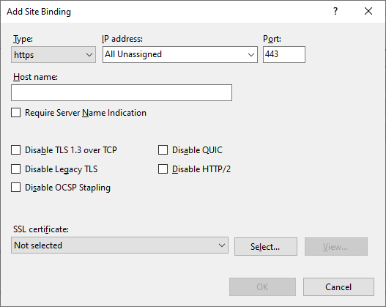

1. In the "SSL certificate" drop down list, select the certificate you just created.

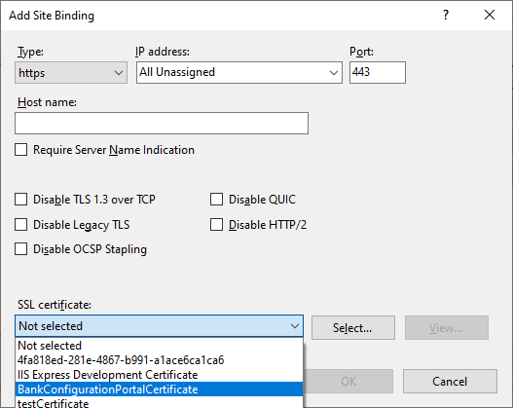

1. Click "OK", then close the bindings window.
2. To browse the site in https, click "Browse *:443" in the connections panel. If you chose a different port number for the binding, it will be shown instead of 443.

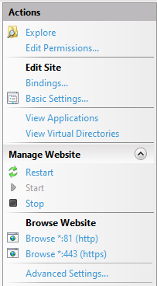

1. You're likely to get a security warning in your browser saying that the connection is not private, since self-signed certificates are not considered to be safe by browsers. You can override that by opening advanced settings and proceeding to the page.

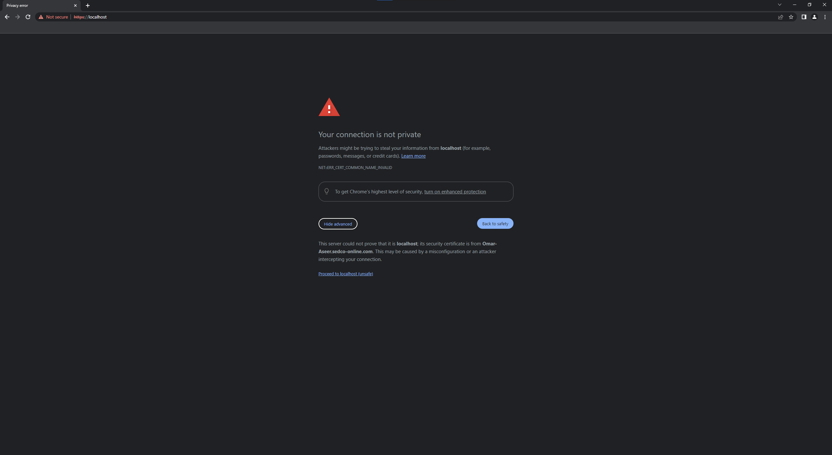

1. You should now be able to access the website.

## Automatic session deletion

To prevent the database from storing expired sessions forever, you can schedule a job using SQL Server Agent to automatically delete expired sessions periodically.

1. Open SSMS and connect to your server.
2. In the "Object Explorer" panel, locate SQL Server Agent and make sure it is enabled. It should have a small green circle with a triangle inside it.

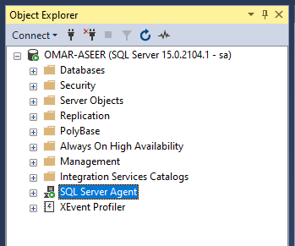

1. If it is disabled, it will show a small red × symbol.

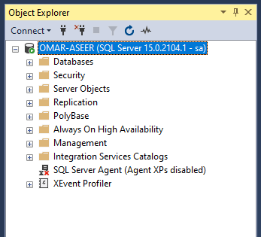

1. If it is disabled, right-click it, then click "Start". You will be asked to confirm your action. Note that you need administrator permission to start this service. Once the service has been started, click the refresh symbol at the top to see the changes.

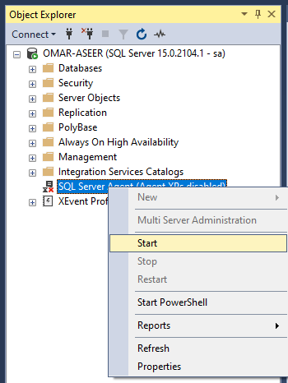

1. Once SQL Server agent has been started, expand it using the + symbol.

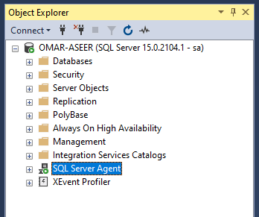

1. Right-click "Jobs", then click "New Job…".

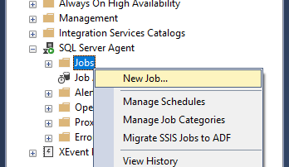

1. In the "New Job" window, type in a name for the job, then click the button with the ellipses (…) next to the "Owner" text box.

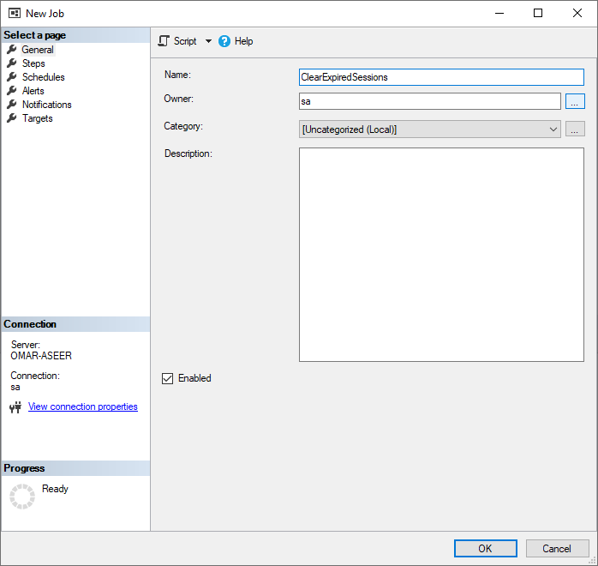

1. In the "Select Login" window, click "Browse…".

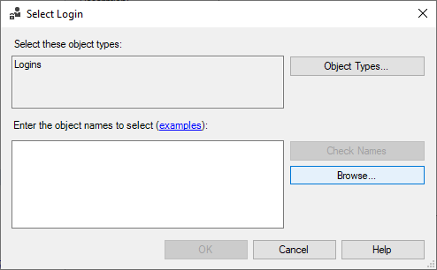

1. Locate the login with the name "[IIS APPPOOL\<your application pool name>]", and check it, then click "OK".

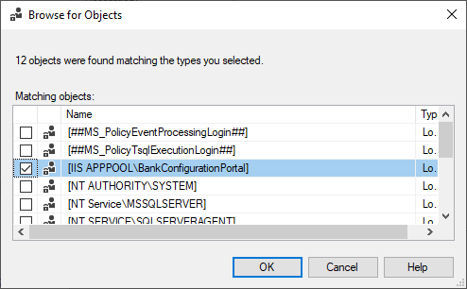

1. Click "OK" in the "Select Login" window.

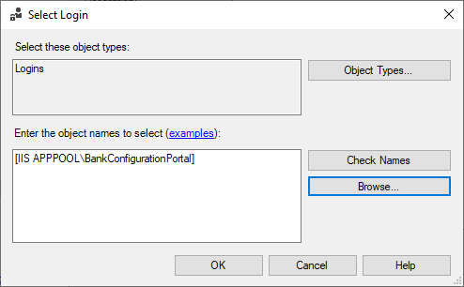

1. Click "Steps" in the left side panel, then click "New…".

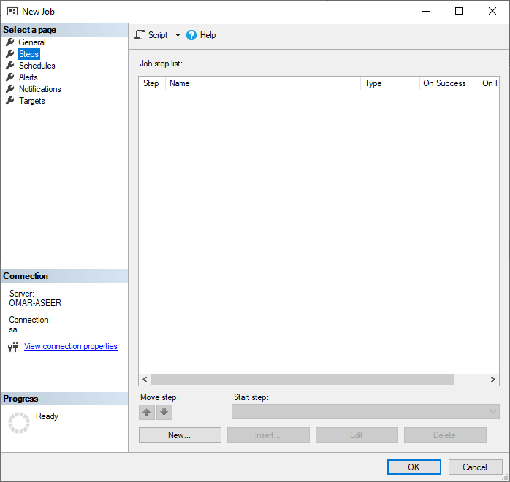

1. Type in a name for the step, select the appropriate database from the dropdown (TSD by default), then type in the following command into the "Command" text box:

DELETE FROM Sessions WHERE expires <= GETDATE();

When you're done, click "OK".

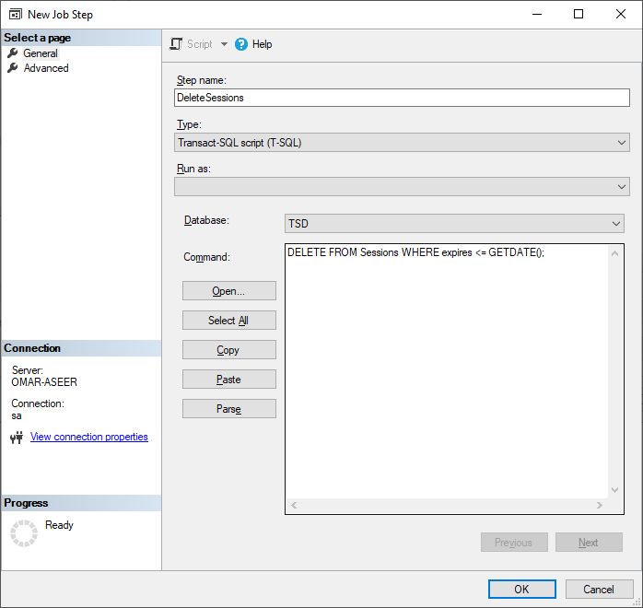

1. Click "Schedules" in the left side panel, then click "New…".

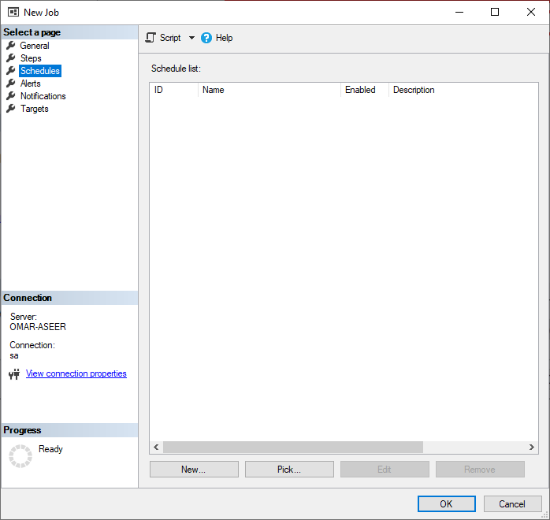

1. Give your schedule a name, then choose the desired frequency. In this example, I choose to set the job to run daily, at 7 pm. When you're done, click "OK".

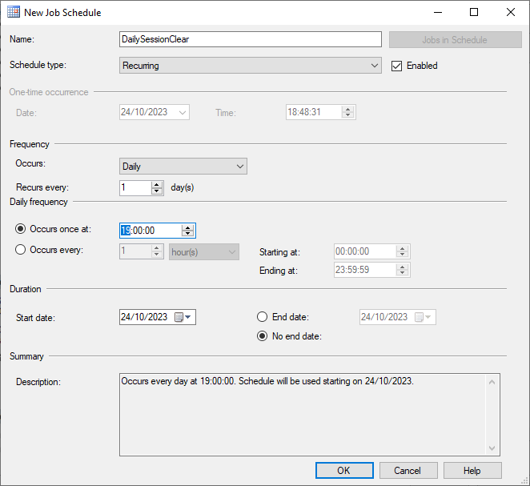

1. Click "OK" in the "New Job" window.

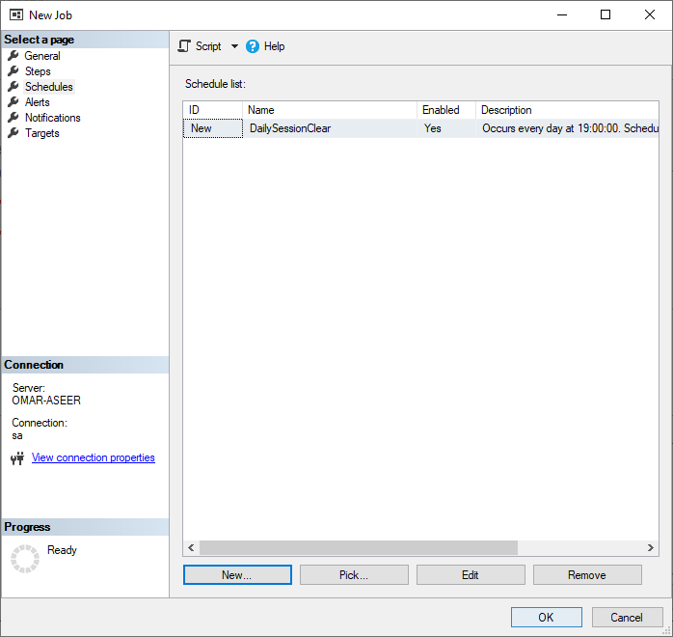

# Login

To perform any actions, you need to log in.

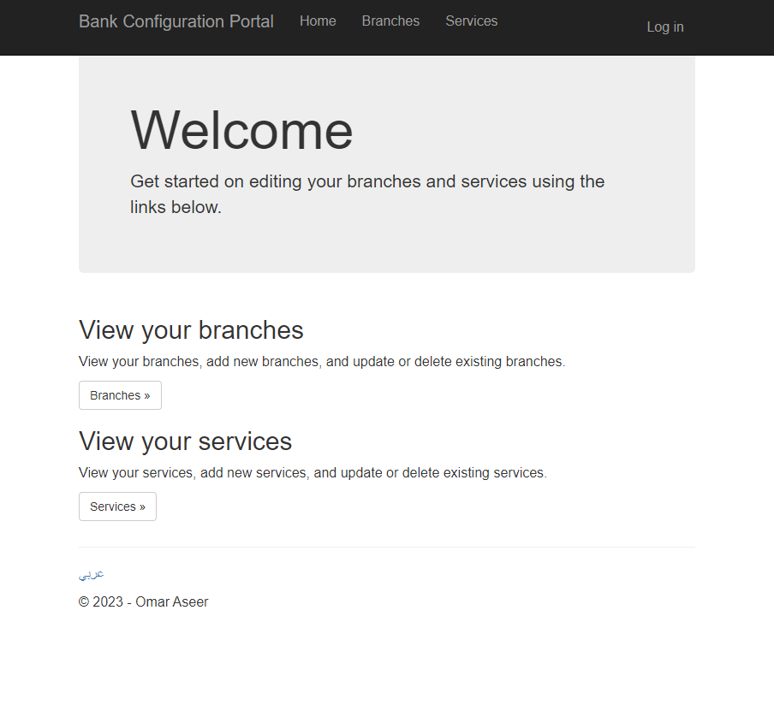

Enter the name of your bank, your username, and your password, then click "Log in".

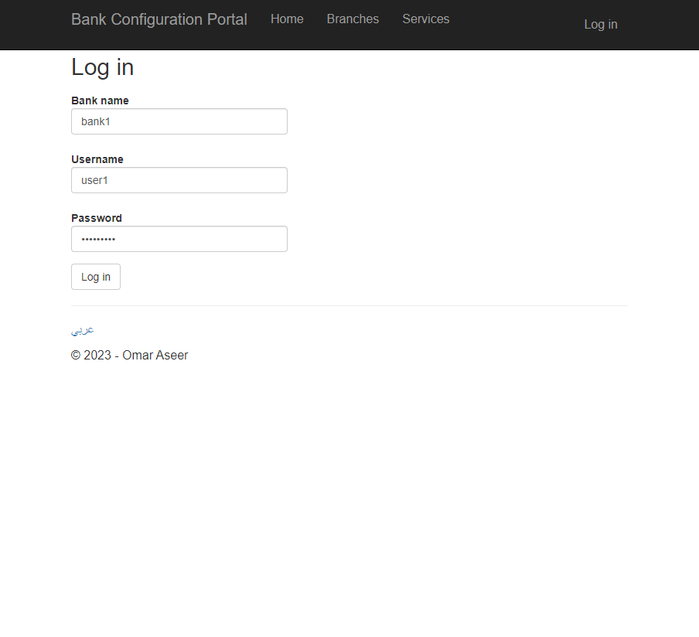

# Branches

Once you’re logged in, you can view, edit, and delete existing branches, and you can create new branches. Click the link in the navigation bar, or the button on the home page.

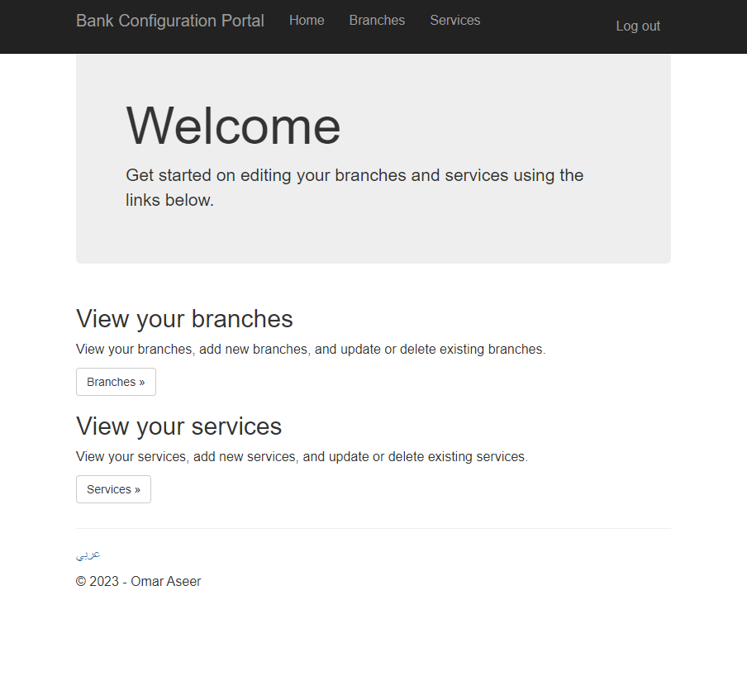

Follow the links on screen to edit, delete, or create branches.

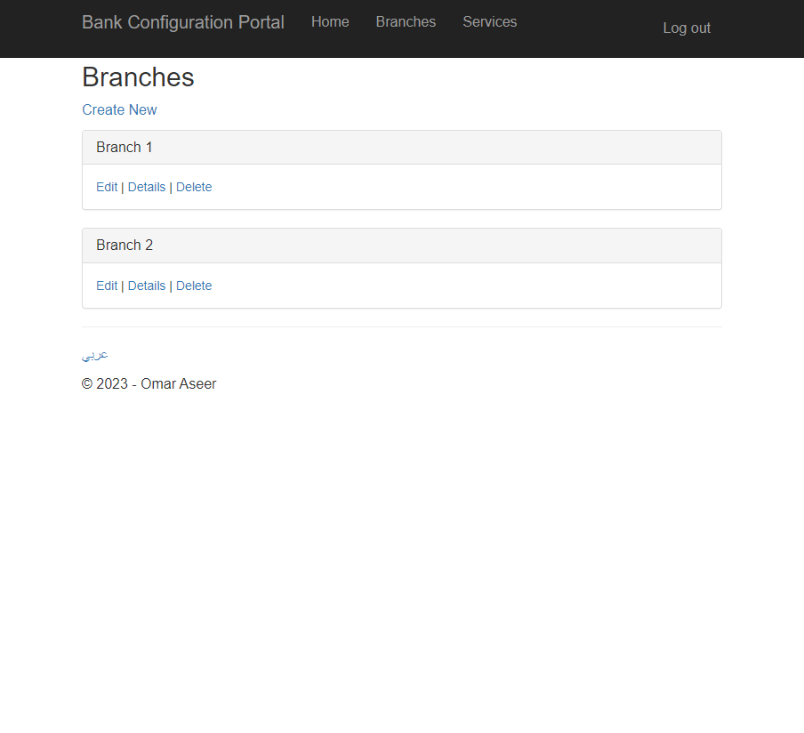

If you want to edit the counters for a specific branch, click the "Details" link for the desired branch, then click "Edit counters".

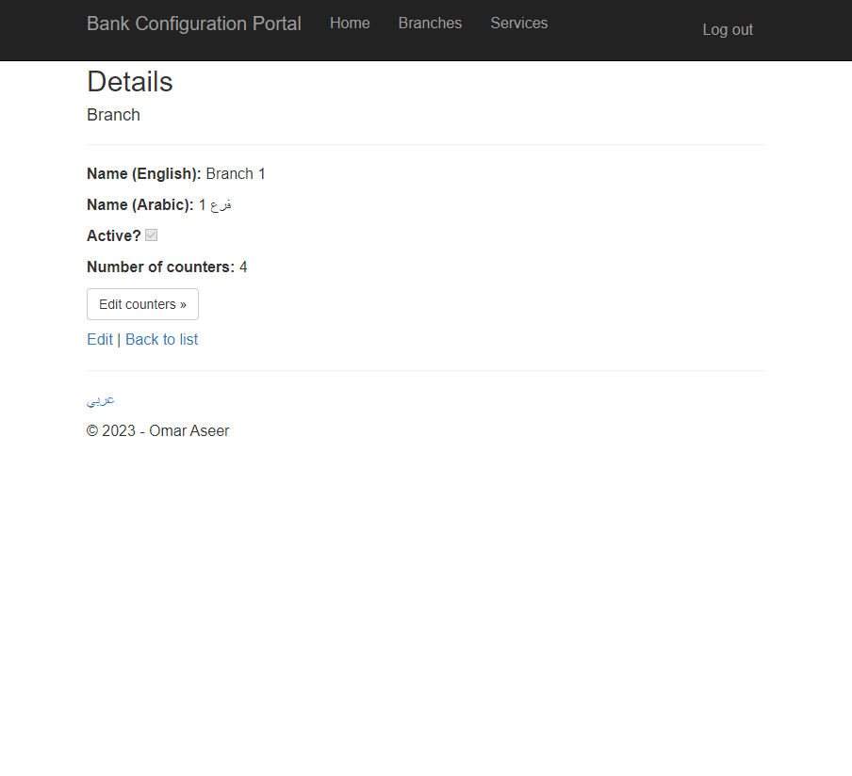

# Counters

Once you’re in the counters page for a specific branch, you can view, edit, and delete existing counters, or add new counters.

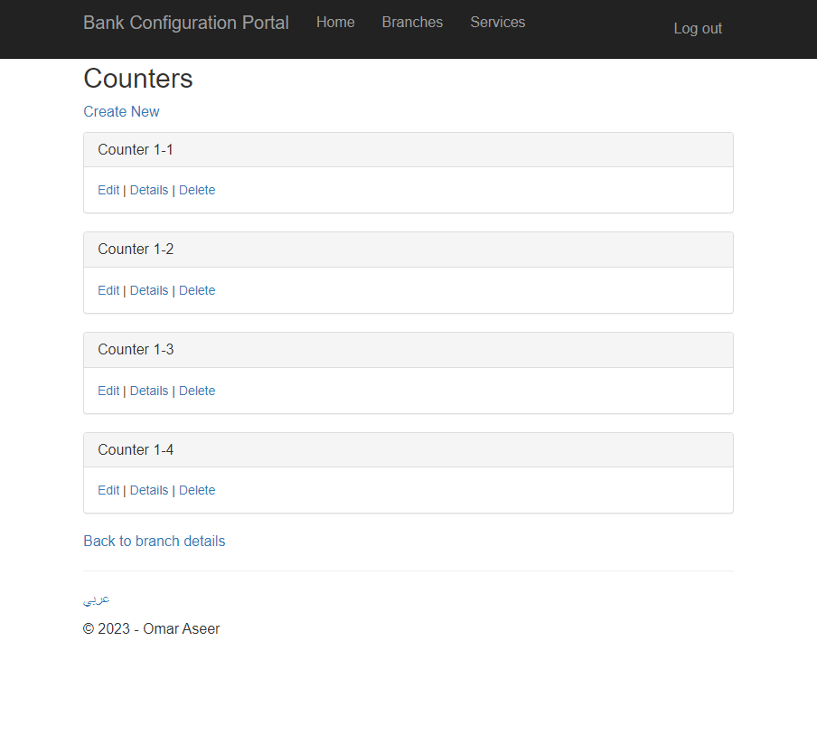

If you would like to allocate services for a specific counter, click the "Details" link for the desired counter. Use the drop down to add new services, or click the × symbol to remove services from the counter.

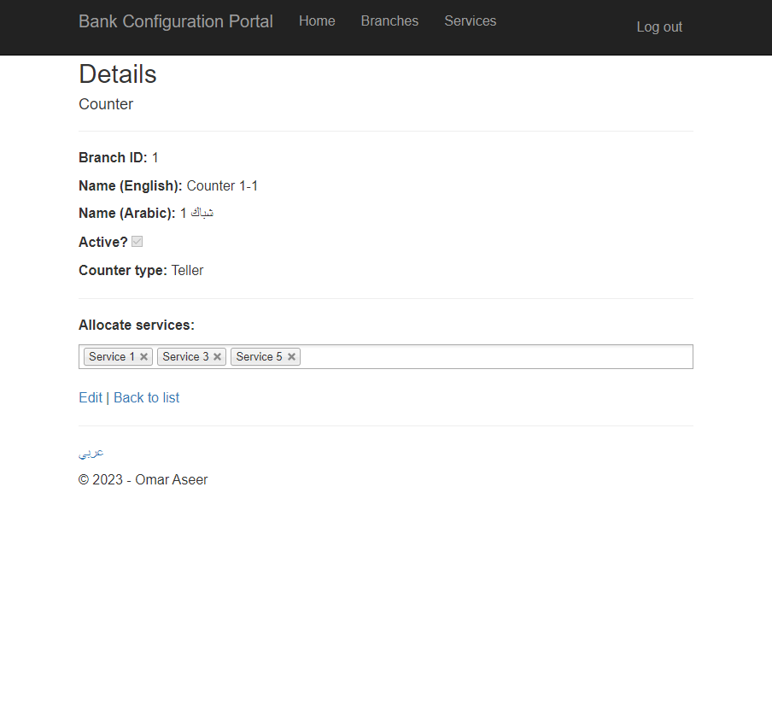

# Services

To view, edit, delete, and add services for your bank, click the link in the navigation bar, or the "Services" button on the home screen.



From the services page, follow the links to add, edit, or delete services.

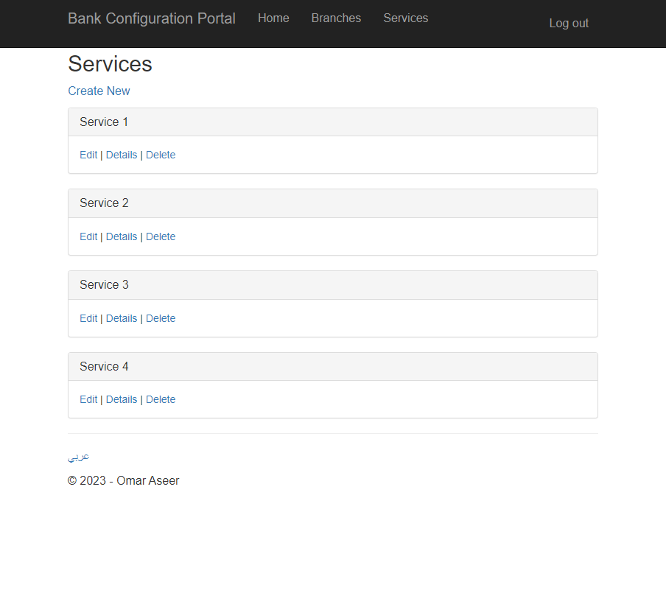

# Language

You can change the language at any time using the link at the bottom of the page.



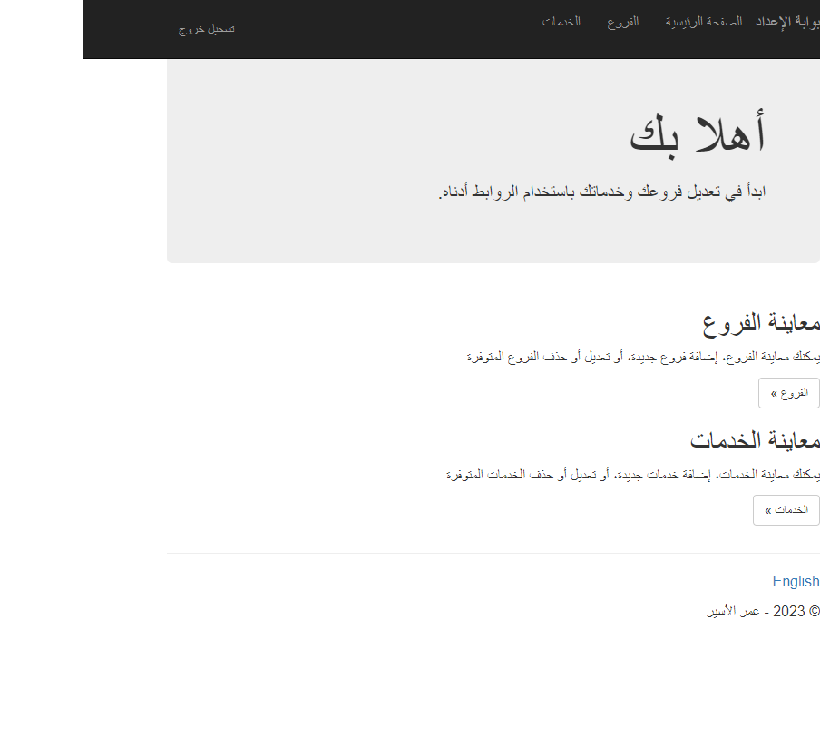

# Using the Screens API

## About the API

The Screens API allows you to retrieve information about the active ticketing screen for your bank, including the buttons that are on that screen. You can filter the buttons by branch ID and counter ID in order to only get the buttons that have services that are supported for a given branch or counter.

## Output sample

Below is an example of the output of the API. This output is formatted as JSON.

{

"BankName": "bank1",

"ScreenId": 45,

"ScreenTitle": "testScreen1",

"ButtonCount": 4,

"Buttons": [

{

"ButtonId": 2,

"Type": "ISSUE_TICKET",

"NameEn": "b",

"NameAr": "لا",

"ServiceId": 1,

"MessageEn": "",

"MessageAr": ""

},

{

"ButtonId": 51658,

"Type": "ISSUE_TICKET",

"NameEn": "d",

"NameAr": "ي",

"ServiceId": 1,

"MessageEn": "",

"MessageAr": ""

},

{

"ButtonId": 51662,

"Type": "SHOW_MESSAGE",

"NameEn": "f",

"NameAr": "ب",

"ServiceId": 0,

"MessageEn": "Message",

"MessageAr": "رسالة"

},

{

"ButtonId": 51663,

"Type": "SHOW_MESSAGE",

"NameEn": "g",

"NameAr": "ل",

"ServiceId": 0,

"MessageEn": "Message",

"MessageAr": "رسالة"

}

]

}

## Authentication

Authentication for the Screens API is performed in the headers. The key of the header is "Authorization", and the value is the credentials, separated by colons, and encoded in base64.

The format of the credentials is "<bankName>:<username>:<password>", without the quotes.

For example, if the name of the bank is 'bank1', the username is 'user1', and the password is 'pass', the decoded credentials will be "bank1:user1:pass". After encoding them in Base64, the string will be "YmFuazE6dXNlcjE6cGFzcw==", without the quotes.

When encoding the credentials, make sure the character set is UTF-8.

Encoding can be done by many methods, including online tools like <https://www.base64encode.org/>.

## Unfiltered results

The format for accessing the screens API is as follows:

https://localhost:<yourPortNumber>/api/Screens

If your port number is 6969, the address will look like this:

https://localhost:6969/api/Screens

## Filtering by branch

To filter the results by a certain branch, include the branch ID in the query string.

https://localhost:<yourPortNumber>/api/Screens?branchId=<yourBranchId>

For example, if your port number is 6969 and the ID of the branch is 45, the address will look like this:

https://localhost:6969/api/Screens?branchId=45

## Filtering by counter

To filter the results by a certain counter, include the ID of the branch where the counter is located, and the ID of the counter itself.

https://localhost:<yourPortNumber>/api/Screens?branchId=<yourBranchId>&counterId=<yourCounterId>

For example, if your port number is 6969, the ID of the branch is 45, and the ID of the counter is 12, the address will look like this:

https://localhost:6969/api/Screens?branchId=45&counterId=12